Chapter 05: Fulfillment

Exercise 05-02: Fulfillment Process

Multiple Company Code

Version 4.15

Revised 01/12/2016

Introduction

General Notes and Information

It is strongly recommended that you read through the entire exercise prior to starting. Not all instructions can be provided in a linear manner in the exercise itself. READ CAREFULLY!

The following symbols are used to indicate important information as described below.

* An arrow highlights an important instruction that must not be overlooked.

🖉 A pencil prompts you to write down an important piece of information.

Each student or group will be assigned a unique two-digit identifier. This identifier is used in all exercises. Whenever you see ##, replace it with your identifier. For example, Joe may have an identifier of 05. Every time Joe sees the ## symbol, he will replace it with “05”.

**Differences in Font**:Throughout this exercise you will see tables with different fonts used in the Data Entry column(s). The normal Times New Roman indicates you enter exactly what is typed out except for the ## Symbol where you would put in your identifier. The italicized *Times New Roman* font indicates the data is looked up, found, or otherwise not to be entered literally as written.

* Always work with your data.
* Provide both the code and its description in your answers. The questions are designed for you to locate the code but also understand the meaning

Business Process Overview

The fulfillment process starts by receiving a customer’s inquiry and then creating an internal sales quotation. This quotation is later converted to a sales order for inventory in the system.

In this exercise, you will execute the fulfillment process.

Exercise Prerequisites

Chapter 04-02 Version MCC 4.10

Chapter 05-01 Version MCC 4.10

Exercise Workflow

Exercise Deliverables

Deliverables are consolidated into one worksheet at the end of the exercise. It is only necessary to turn in that worksheet and that worksheet alone along with data in the system if required.

For this exercise you will need the following deliverables:

In the System:

* Sales Quotation Created
* Sales Order Created
* Outbound Delivery Created
* Shipment Sent to Customer
* Invoice Sent to Customer
* Customer Account Paid Off

On Paper:

* Answer(s) to Question(s)
* Check Filled Out
* Document Number(s)
* You may be assigned additional deliverables. Make certain to check with your instructor.

Step 1: Receive Inquiry

In this step, you look over the customer inquiry that you received. This step has no SAP activity associated with it. You have received the following sales inquiry from a customer which is requesting a price quotation for a list of products. These products consist of trading goods.

To Whom It May Concern:

My Name is Jeremy Jones and I am a purchasing agent for DC Bikes in our nation’s capital. I was looking through your catalog and would like to receive a quote for the following items:

|  |  |  |
| --- | --- | --- |
| Material Description | Material Number | Quantity |
| ## Elbow Pads | EPAD10## | 20 |
| ## Road Helmet | RHMT10## | 15 |
| ## Repair Kit | RKIT10## | 12 |

A quote by email or fax would be ideal.

Thanks,

Jeremy Jones

Purchasing Agent

DC Bikes

1300, Pennsylvania Ave

Washington DC 20004

Fax: (517)-555-1234

* This step has no SAP activity associated with it

Exercise Deliverables

In the System:

* None

On Paper:

* None

Step 2: Create Quotation

In this step, you create a quotation in response to the inquiry you received in the previous step. This step involves creating a quotation and forwarding it to the customer. For this exercise, the quote will be printed out. Alternatively, it could be transmitted electronically.

1. In the “SAP Easy Access” screen, follow the navigation path below:

Navigation

Logistics 🡪 Sales and Distribution 🡪 Sales 🡪 Quotation 🡪 Create

1. What is the transaction code to create a sales quotation?VA21 🖉
2. What is the transaction code to change a sales quotation? VA22 🖉
3. What is the transaction code to display a sales quotation? VA23 🖉
4. You are in the “Create Quotation: Initial Screen” screen.

Enter the following information:

|  |  |
| --- | --- |
| Field Name | Data Entry |
| Quotation Type | Quotation |
| Sales Organization | Your US East |
| Distribution Channel | Wholesale |
| Division | Accessories |

1. Click on  (ENTER).
2. In the “Create Quotation: Overview” screen, enter the following information:

|  |  |
| --- | --- |
| Field Name | Data Entry |
| Sold-To Party | Your DC Bikes |
| Valid to | One Month from Today |

1. At the bottom of the screen, enter the following information:

|  |  |
| --- | --- |
| Material | Order Quantity |
| Your Elbow Pads | Quantity Requested from Inquiry |
| Your Road Helmet | Quantity Requested from Inquiry |
| Your Repair Kit | Quantity Requested from Inquiry |

1. Click on  (ENTER).
2. Click on  (SAVE).

You will receive a message that says “Quotation has been saved”.

1. What is the resulting document number? 20000540 🖉
2. Type “/nVA23” in the 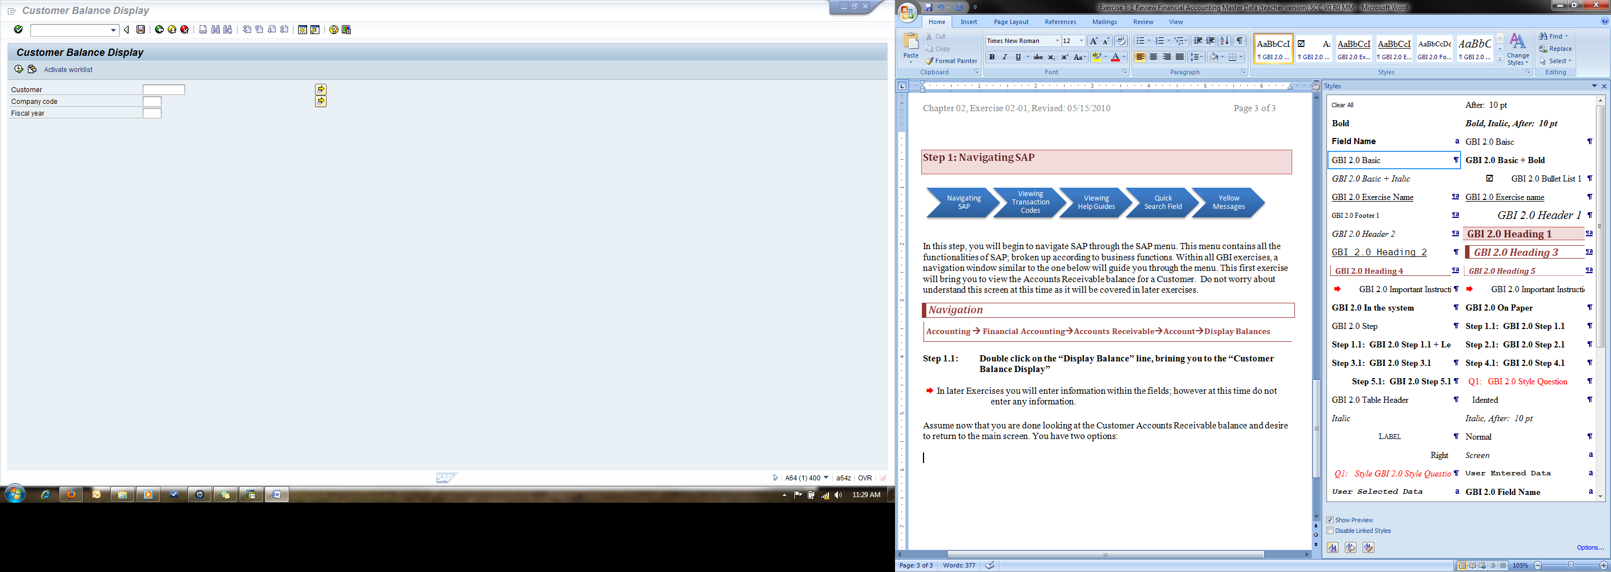 (COMMAND LINE) field.
3. Click on  (ENTER).
4. In the “Display Quotation: Initial Screen” screen, click on the  icon.
5. At the top of the screen, click on Environment.
6. Click on Display Document Flow.

* Pressing F5 or clicking  will also bring up the document flow.
* The screen displays the current status of the order. Throughout the exercise, you will view
* the document flow to see how the status changes as we complete more of the process steps.
* Ensure your cursor is in the document number box, and not one of the line items.

1. What is the quotation’s current status? Open 🖉

* Refer to a previous step in a previous exercise for instructions on how to review material inventory. Review the inventory of your elbow pads, road helmets, and repair kits to answer the following questions. While the balance in your inventory may be obvious, it is always good to check for grading purposes.

1. How many elbow pads are in unrestricted stock? 0 🖉
2. How many road helmets are in unrestricted stock? 50 🖉
3. How many repair kits are in unrestricted stock? 50 🖉

* You will be asked to review inventory amounts throughout this exercise. To open an additional session, click the  icon on the top to do so. When asked for an inventory amount, you simply click  (Back), then click  (Execute) once again to get the most current amounts.
* Refer to a previous step in a previous exercise for instructions on how to review customer balances. Review the account balance of your customer to answer the following questions. While the balance in your customer’s account may be obvious, it is always good to check.

1. What is the balance in your customer’s account? No balance for customer 🖉
2. What is the current DC Bike’s debit balance? No balance 🖉

Exercise Deliverables:

In the System:

* Sales Quotation Created

On Paper:

* Answer(s) to Question(s)
* Document Number(s)

Step 3: Receive Order

In this step, you look over the order received from the customer you had previously sent a quotation to. You now receive the following purchase order from your customer wanting to purchase the following materials. This step has no SAP activity associated with it.

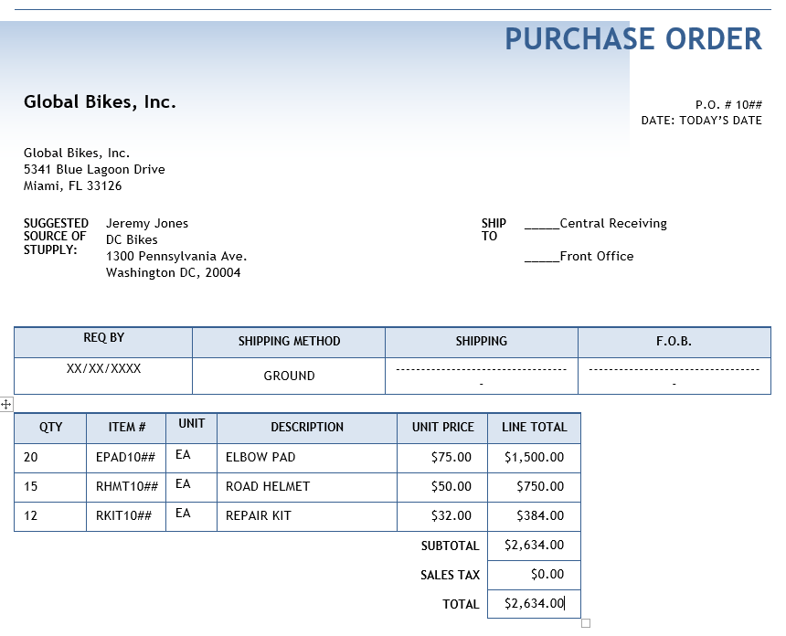

Exercise Deliverables:

In the System:

* None

On Paper:

* Answer(s) to Question(s)

Step 4: Sales Order

In this step, you create a sales order from the purchase order you received in the previous step. You can now create a sales order by referencing the quotation created in Step 2. If necessary, you can add or delete line items and change quantities. The reference reduces more work.

1. In the “SAP Easy Access” screen, follow the navigation path below:

Navigation

Logistics 🡪 Sales and Distribution 🡪 Sales 🡪 Order 🡪 Create

1. What is the transaction code to create a sales order? VA01 🖉
2. What is the transaction code to change a sales order? VA02 🖉
3. What is the transaction code to display a sales order? VA03 🖉
4. You are in the “Create Sales Order: Initial Screen” screen.

Enter the following information:

|  |  |
| --- | --- |
| Field Name | Data Entry |
| Order Type | OR |
| Sales Organization | UE## |
| Distribution Channel | WH |
| Division | AS |

1. Click on  (CREATE WITH REFERENCE).
2. In the “Create with Reference” pop-up, enter the following information:

|  |  |
| --- | --- |
| Field Name | Data Entry |
| Quot. | Your Quotation Number |

1. Click on  (COPY).
2. You are in the “Create Standard Order: Overview” screen.

Enter the following information:

|  |  |
| --- | --- |
| Field Name | Data Entry |
| PO Number | Purchase Order Number from Previous Step |

1. Click on  (ENTER).
2. What is the net value of the sales order? 2,580.00 USD 🖉
3. What are the payment terms? 0001 Pay immediately w/o dIncoterm 🖉
4. Click on  (SAVE).

You will receive a message that says “Standard Order has been saved”.

1. What is the resulting document number? 13 🖉

* Refer to a previous exercise on how to display the document flow for sales documents.

1. What is the quotation’s current status? Completed 🖉

* Refer to a previous step in a previous exercise for instructions on how to review material inventory. Review the inventory of your elbow pads, road helmets, and repair kits to answer the following questions. While the balance in your inventory may be obvious, it is always good to check for grading purposes.

1. How many elbow pads are in unrestricted stock? No stock exist 🖉
2. How many road helmets are in unrestricted stock? No stock exist 🖉
3. How many repair kits are in unrestricted stock? No stock exist 🖉

* Refer to a previous step in a previous exercise for instructions on how to review customer balances. Review the account balance of your customer to answer the following questions. While the balance in your customer’s account may be obvious, it is always good to check.

1. What is DC Bike’s current debit balance? No balance 🖉

Exercise Deliverables:

In the System:

* Sales Order Created

On Paper:

* Answer(s) to Question(s)
* Document Number(s)

Step 5: Prepare Shipment

In this step, you prepare shipment for the sales order you received by picking and packing the appropriate goods from their appropriate storage locations. You will then send an invoice later.

1. In the “SAP Easy Access” screen, follow the navigation path below:

Navigation

Logistics 🡪 Sales and Distribution 🡪 Shipping and Transportation 🡪 Outbound Delivery 🡪 Create 🡪 Single Document 🡪 With Reference to Sales Order

1. What is the transaction code to pick and pack materials? VL01N 🖉
2. You are in the “Create Outbound Delivery with Order Reference” screen.

Enter the following information:

|  |  |
| --- | --- |
| Field Name | Data Entry |
| Shipping point | Your Miami |
| Selection Date | Today’s Date |
| Order | Your Sales Order Number |

1. Click on  (ENTER).
2. You are in the “Outbound Delivery Create: Overview” screen.

Click on the “Picking” tab.

1. Enter the following information:

|  |  |  |
| --- | --- | --- |
| Material | SLoc | Picked Quantity |
| **Your Elbow Pads** | Your Trading Goods | Desired Quantity |
| **Your Road Helmet** | Your Trading Goods | Desired Quantity |
| **Your Repair Kit** | Your Trading Goods | Desired Quantity |

1. Click on  (SAVE).

You will receive a message that says “Outbound Delivery has been saved”.

1. What is the resulting document number? EPAD1054 does not exist 🖉

* Refer to a previous exercise on how to display the document flow for sales documents.

1. What is the standard order’s current status?       🖉

* Refer to a previous step in a previous exercise for instructions on how to review material inventory. Review the inventory of your elbow pads, road helmets, and repair kits to answer the following questions. While the balance in your inventory may be obvious, it is always good to check for grading purposes.

1. How many elbow pads are in unrestricted stock?       🖉
2. How many road helmets are in unrestricted stock?       🖉
3. How many repair kits are in unrestricted stock?       🖉

* Refer to a previous step in a previous exercise for instructions on how to review customer balances. Review the account balance of your customer to answer the following questions. While the balance in your customer’s account may be obvious, it is always good to check.

1. What is DC Bike’s current debit balance? No data for balance 🖉

Exercise Deliverables:

In the System:

* Outbound Delivery Created

On Paper:

* Answer(s) to Question(s)
* Document Number(s)

Step 6: Send Shipment

In this step, you send the shipment of goods to fulfill your order to your customer. Creating the post goods issue (shipping) reduces unrestricted stock to reflect the quantity shipped. It also indicates a change in the ownership of the goods which reflects liability and responsibility.

1. In the “SAP Easy Access” screen, follow the navigation path below:

Navigation

Logistics 🡪 Sales and Distribution 🡪 Shipping and Transportation 🡪 Outbound Delivery 🡪 Change 🡪 Single Document

1. What is the transaction code to post the goods issue? VL02N 🖉

* Be sure that your outbound delivery number is defaulted in the field.

1. In the “Change Outbound Delivery” screen, click on the  icon. You will receive a message that says “Outbound Delivery has been saved”.

* Refer to a previous exercise on how to display the document flow for sales documents.

1. What is the outbound delivery’s current status? Open 🖉

* Refer to a previous step in a previous exercise for instructions on how to review material inventory. Review the inventory of your elbow pads, road helmets, and repair kits to answer the following questions. While the balance in your inventory may be obvious, it is always good to check for grading purposes.

1. How many elbow pads are in unrestricted stock?       🖉
2. How many road helmets are in unrestricted stock?       🖉
3. How many repair kits are in unrestricted stock?       🖉

* Refer to a previous step in a previous exercise for instructions on how to review customer balances. Review the account balance of your customer to answer the following questions. While the balance in your customer’s account may be obvious, it is always good to check.

1. What is DC Bike’s current debit balance?       🖉

Exercise Deliverables:

In the System:

* Shipment Sent to Customer

On Paper:

* Answer(s) to Question(s)

Step 7: Send Invoice

In this step, you create and send an invoice to your customer for the goods that they purchased. Once the post goods issue has been generated, you can bill your customer for the shipped goods.

1. In the “SAP Easy Access” screen, follow the navigation path below:

Navigation

Logistics 🡪 Sales and Distribution 🡪 Billing 🡪 Billing Document 🡪 Create

1. What is the transaction code to create a billing document? VF01 🖉
2. In the “Create Billing Document” screen, click on the  icon. You will receive a message that says “Document has been saved”.
3. What is the resulting document number?       🖉

* Refer to a previous exercise on how to display the document flow for sales documents.

1. What is the invoice’s current status?       🖉
2. What is the accounting document’s current status?       🖉

* Refer to a previous step in a previous exercise for instructions on how to review material inventory. Review the inventory of your elbow pads, road helmets, and repair kits to answer the following questions. While the balance in your inventory may be obvious, it is always good to check for grading purposes.

1. How many elbow pads are in unrestricted stock?       🖉
2. How many road helmets are in unrestricted stock?       🖉
3. How many repair kits are in unrestricted stock?       🖉

* Refer to a previous step in a previous exercise for instructions on how to review customer balances. Review the account balance of your customer to answer the following questions. While the balance in your customer’s account may be obvious, it is always good to check.

1. What is the total in the debit column of the DC Bike’s account?       🖉
2. What is the total in the credit column of the DC Bike’s account?       🖉

Exercise Deliverables:

In the System:

* Invoice Sent to Customer

On Paper:

* Answer(s) to Question(s)
* Document Number(s)

Step 8: Receive Payment

In this step, you receive a payment from your customer and look over the check that was sent. This step has no SAP activity associated with it. You have now received the following check:

YOUR FRIENDLY LOCAL BANK DATE___/___/_____

123 MAIN STREET No. 1357

ANYWHERE, MI 48710

Pay to the order of Global Bikes Inc. **🖉** $2634.00_____

Note_______________ Signature: ___________________

The check has been signed by the account payable manager for DC Bikes. When you receive this check, you must post the payment in the accounting records. This is done in the next step.

Exercise Deliverables:

In the System:

* None

On Paper:

* Check Filled Out

Step 9: Post Payment

In this step, the customer has received the invoice and sent you a payment. This will be posted to the company’s general ledger account. You look at this new balance at the end.

1. In the “SAP Easy Access” screen, follow the navigation path below:

Navigation

Accounting 🡪 Financial Accounting 🡪 Accounts Receivable 🡪 Document Entry 🡪 Incoming Payments

1. What is the transaction code to receive a customer payment?       🖉
2. You are in the “Post Incoming Payments: Header Data” screen.

Enter the following information:

|  |  |
| --- | --- |
| Field Name | Data Entry |
| Document Date | Today’s Date |
| Bank data Account | Your Bank Account |
| Amount | Amount this Customer has Paid |
| Open item selection Account | Your DC Bikes |

1. Click on  (ENTER).

You will receive a message that says “1 Item was selected”.

* The following screen shows you the unpaid invoices from this customer. In the bottom right part of the screen, the amount entered should equal the assigned amount and thus would make the not assigned amount zero. If the not assigned amount is not equal to zero, click on the amount under the “USD Gross” column. This will tell you if there is more than one listed.

1. In the “Post Incoming Payments Process open” screen click on the  icon.

You will receive a message that says “Document was posted in company”.

1. What is the resulting document number?       🖉

* Refer to a previous exercise on how to display the document flow for sales documents.

1. What is the accounting document’s current status?       🖉

* Refer to a previous step in a previous exercise for instructions on how to review material inventory. Review the inventory of your elbow pads, road helmets, and repair kits to answer the following questions. While the balance in your inventory may be obvious, it is always good to check for grading purposes.

1. How many elbow pads are in unrestricted stock?       🖉
2. How many road helmets are in unrestricted stock?       🖉
3. How many repair kits are in unrestricted stock?       🖉

* Refer to a previous step in a previous exercise for instructions on how to review customer balances. Review the account balance of your customer to answer the following questions. While the balance in your customer’s account may be obvious, it is always good to check.

1. What is the total in the debit column of the DC Bike’s account?       🖉
2. What is the total in the credit column of the DC Bike’s account?       🖉

Exercise Deliverables:

In the System:

* Customer Account Paid Off

On Paper:

* Answer(s) to Question(s)
* Document Number(s)

Attachment 1: Exercise Worksheet

**Name:** Thuy Hong Ha

**Course and Section:** Ch-05-02

**Identifier:** 54

**Client:** 516

* Provide both the code and its description in your answers. The questions are designed for you to locate the code but also understand the meaning

1. What is the transaction code to create a sales quotation? 🖉
2. What is transaction code to change a sales quotation? 🖉
3. What is the transaction code to display a sales quotation? 🖉
4. What is the resulting document number? 🖉
5. What is the quotation’s current status? 🖉
6. How many elbow pads are in unrestricted stock? 🖉
7. How many road helmets are in unrestricted stock? 🖉
8. How many repair kits are in unrestricted stock? 🖉
9. What is the balance in your customer’s account? 🖉
10. What is the current DC Bikes debit balance? 🖉
11. What is the transaction code to create a sales order? 🖉
12. What is transaction code to change a sales order? 🖉
13. What is the transaction code to display a sales order? 🖉
14. What is the net value of the sales order? 🖉
15. What are the payment terms? 🖉
16. What resulting document number? 🖉
17. What is the quotation’s current status? 🖉
18. How many elbow pads are in unrestricted stock? 🖉
19. How many road helmets are in unrestricted stock? 🖉
20. How many repair kits are in unrestricted stock? 🖉
21. What is the current DC Bike’s debit balance? 🖉
22. What is the transaction code to pick and pack materials? 🖉
23. What resulting document number? 🖉
24. What is the standard order’s current status? 🖉
25. How many elbow pads are in unrestricted stock? 🖉
26. How many road helmets are in unrestricted stock? 🖉
27. How many repair kits are in unrestricted stock? 🖉
28. What is the current DC Bike’s debit balance? 🖉
29. What is the transaction code to post the good’s issue? 🖉
30. What is the outbound delivery’s current status? 🖉
31. How many elbow pads are in unrestricted stock? 🖉
32. How many road helmets are in unrestricted stock? 🖉
33. How many repair kits are in unrestricted stock? 🖉
34. What is the current DC Bike’s debit balance? 🖉
35. What is the transaction code to create a billing document? 🖉
36. What is the resulting document number? 🖉
37. What is the invoice’s current status? 🖉
38. What is the accounting document’s current status? 🖉
39. How many elbow pads are in unrestricted stock? 🖉
40. How many road helmets are in unrestricted stock? 🖉
41. How many repair kits are in unrestricted stock? 🖉
42. What is the current DC Bike’s debit balance? 🖉
43. What is the current DC Bike’s credit balance? 🖉
44. What is transaction code to receive a customer payment? 🖉
45. What is the resulting document number? 🖉
46. What is the accounting document’s current status? 🖉
47. How many elbow pads are in unrestricted stock? 🖉
48. How many road helmets are in unrestricted stock? 🖉
49. How many repair kits are in unrestricted stock? 🖉
50. What is the current DC Bike’s debit balance? 🖉
51. What is the current DC Bike’s credit balance? 🖉